Assignment 1

Que 1) creating sample table and inserting values
create and inserting salespeople
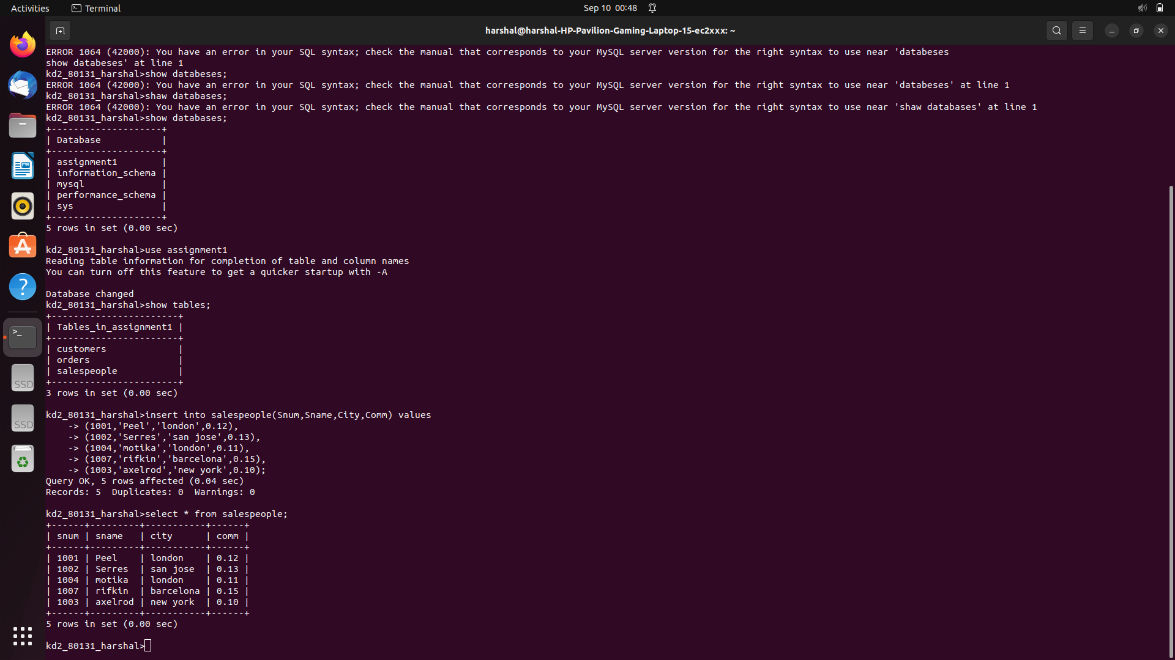
Que 2 create and inserting customers
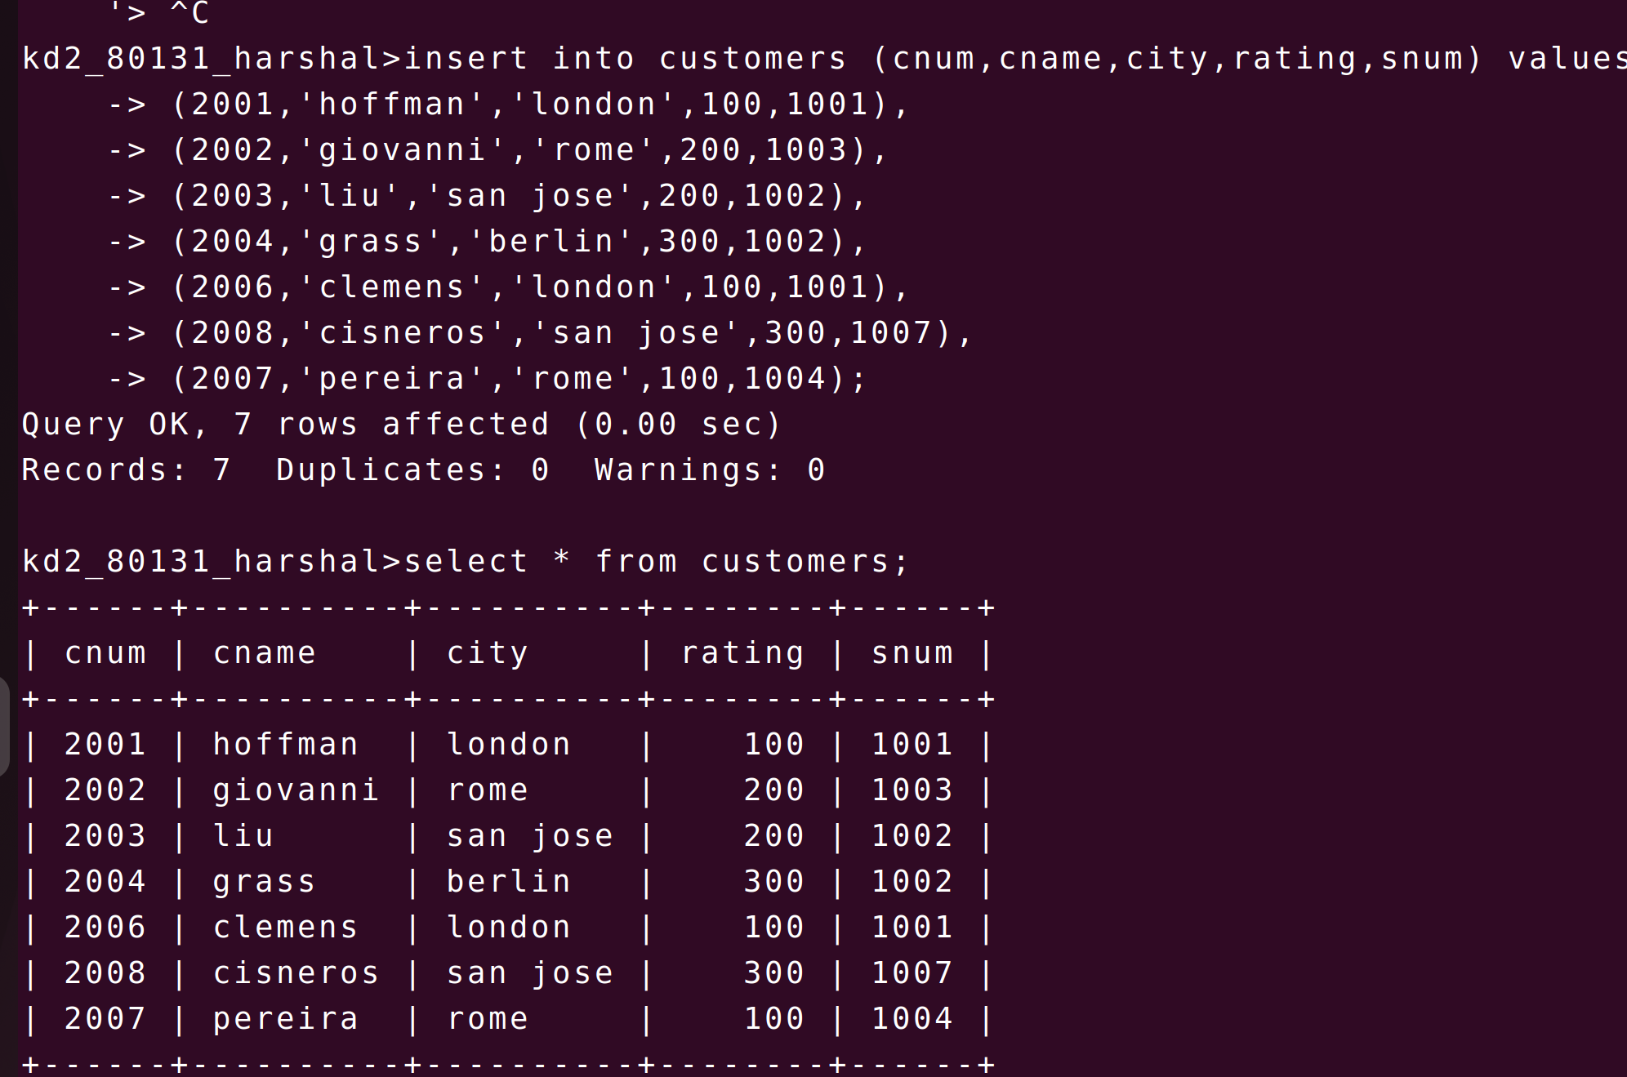
Que 3 create and inserting orders

